**DATA & SIGNALS**

**-**To be transmitted, data must be transformed to electromagnetic signals.

**Data can be Analog or Digital.**

1. **Analog data** refers to information that is continuous; ex. sounds made by a human voice

2. **Digital data** refers to information that has discrete states. Digital data take on discrete values.

**Signals can be of two types:**

1. **Analog Signal:** They have infinite values in a range.

2. **Digital Signal:** They have limited number of defined values

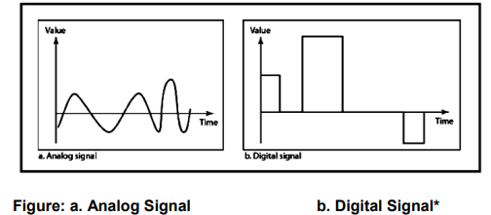

**Periodic & Non-Periodic Signals**

Signals which repeat itself after a fixed time period are called **Periodic Signals**

Signals which do not repeat itself after a fixed time period are called **Non-Periodic Signals.**

In data communications, we commonly use periodic analog signals and non-periodic digital signals.

**Characteristics of an Analog Signal**

**1.Amplitude** - The amplitude of a signal is the absolute value of its intensity at time t. The peak amplitude of a signal is the absolute value of the highest intensity.

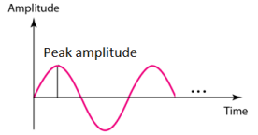

**2. Frequency** - refers to the number of cycles completed by the wave in one second.

**3.Period** refers to the time taken by the wave to complete one second

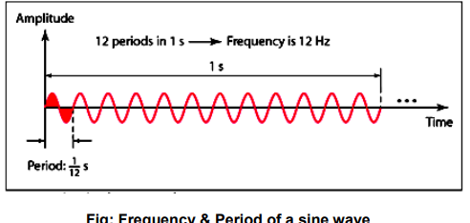

**4. Phase -** Phase describes the position of the waveform with respect to time (specifically relative to time O). Phase indicates the forward or backward shift of the waveform from the axis. It is measured in degrees or radian.

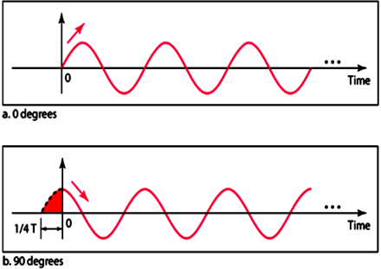

**5. Wavelength**

The wavelength is the distance a signal travels in one period. The wavelength of a signal refers to the relationship between frequency (or period) and propagation speed of the wave through a medium.

**Transmission of Digital signal**

1. **Baseband Transmission**

The signal is transmitted without making any change to it (ie. Without modulation). In baseband transmission, the bandwidth of the signal to be transmitted has to be less than the bandwidth of the channel.

1. **Broad band Transmission**

Given a bandpass channel, a digital signal cannot be transmitted directly through it. In broadband transmission we use modulation, i.e we change the signal to analog signal before transmitting it. The digital signal is first converted to an analog signal, since we have a bandpass channel we cannot directly send this signal through the available channel.

**BANDWIDTH OF A SIGNAL**

Bandwidth can be defined as the portion of the electromagnetic spectrum occupied by the signal. It may also be defined as the frequency range over which a signal is transmitted. Different types of signals have different bandwidth. Ex. Voice signal, music signal, etc Bandwidth of analog and digital signals are calculated in separate ways; analog signal bandwidth is measured in terms of its frequency (hz) but digital signal bandwidth is measured in terms of bit rate (bits per second, bps). Bandwidth of signal is different from bandwidth of the medium/channel

**Bandwidth of an analog signal -** Bandwidth of an analog signal is expressed in terms of its frequencies. It is defined as the range of frequencies that the composite analog signal carries. It is calculated by the difference between the maximum frequency and the minimum frequency. It has a minimum frequency of F1 = 30Hz and maximum frequency of F2 = 90Hz.

**Bandwidth of a digital signal -** It is defined as the maximum bit rate of the signal to be transmitted. It is measured in bits per second.

**BANDWIDTH OF A CHANNEL**

A channel is the medium through which the signal carrying information will be passed. In terms of analog signal, bandwidth of the channel is the range of frequencies that the channel can carry. In terms of digital signal, bandwidth of the channel is the maximum bit rate supported by the channel. i.e. the maximum amount of data that the channel can carry per second. The bandwidth of the medium should always be greater than the bandwidth of the signal to be transmitted else the transmitted signal will be either attenuated or distorted or both leading in loss of information. The channel bandwidth determines the type of signal to be transmitted i.e. analog or digital.

**THE MAXIMUM DATA RATE OF A CHANNEL**

Data rate depends on three factors:

* The bandwidth available
* The level of the signals we use
* The quality of the channel (the level of noise)

The quality of the channel indicates two types:

**a) A Noiseless or Perfect Channel -** An ideal channel with no noise. The Nyquist Bit rate derived by Henry Nyquist gives the bit rate for a Noiseless Channel.

**b) A Noisy Channel -** A realistic channel that has some noise. The Shannon Capacity formulated by Claude Shannon gives the bit rate for a Noisy Channel

**Nyquist Bit Rate**

The Nyquist bit rate formula defines the theoretical maximum bit rate for a noiseless channel

*Bitrate = 2 x Bandwidth x Log2 L*

Where,

* Bitrate is the bitrate of the channel in bits per second
* Bandwidth is the bandwidth of the channel
* L is the number of signal levels.

Example

What is the maximum bit rate of a noiseless channel with a bandwidth of 5000 Hz transmitting a signal with two signals

levels.

Solution:

The bit rate for a noiseless channel according to Nyquist Bit rate can be calculated as follows:

BitRate = 2 x Bandwidth x Log2 L

= 2 x 5000 x log2 2 =10000 bps

**Shannon Capacity**

The Shannon Capacity defines the theoretical maximum bit rate for a noisy channel

*Capacity=bandwidth X log2 (1 +SNR)*

Where,

* Capacity is the capacity of the channel in bits per second
* Bandwidth is the bandwidth of the channel
* SNR is the Signal to Noise Ratio

Shannon Capacity for calculating the maximum bit rate for a noisy channel does not consider the number of levels of the

signals being transmitted as done in the Nyquist bit rate.

Example:

Calculate the bit rate for a noisy channel with SNR 300 and bandwidth of 3000Hz

Solution:

The bit rate for a noisy channel according to Shannon Capacity can be calculated as follows:

*Capacity=bandwidth X log2 (1 +SNR)*

= 3000 x log2 (1 + 300)

= 3000 x log2 (301)

= 3000 x 8.23

= 24,690bps

**SIGNAL ENCODING**

Signal encoding is the conversion from analog/digital data to analog / digital signal.

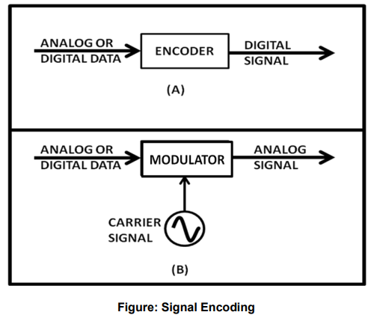

The possible encodings are:

* Digital data to Digital Signal
* Digital data to Analog Signal
* Analog data to Digital Signal
* Analog data to Analog Signal

**Digital Data to Digital Signal**

* Non Return to Zero NRZ

NRZ Codes has **1** for High voltage level and **0** for Low voltage level. The main behavior of NRZ codes is that the voltage level remains constant during bit interval. The end or start of a bit will not be indicated and it will maintain the same voltage state, if the value of the previous bit and the value of the present bit are same.

### **NRZ - I NRZ–INVERTED**

If a **1** occurs at the incoming signal, then there occurs a transition at the beginning of the bit interval. For a **0** at the incoming signal, there is no transition at the beginning of the bit interval.

### **Bi-phase Manchester**

In this type of coding, the transition is done at the middle of the bit-interval. The transition for the resultant pulse is from High to Low in the middle of the interval, for the input bit 1. While the transition is from Low to High for the input bit **0**.

### **Differential Manchester**

### In this type of coding, there always occurs a transition in the middle of the bit interval. If there occurs a transition at the beginning of the bit interval, then the input bit is **0**. If no transition occurs at the beginning of the bit interval, then the input bit is **1**.

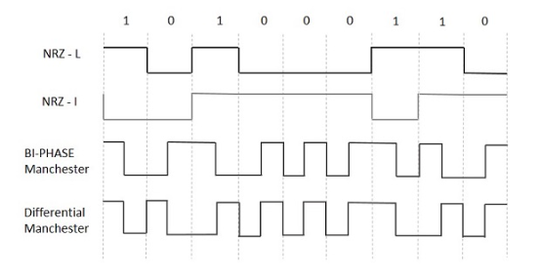

**Analog data to analog signal**

**Modulation -** The Process of converting analog data to analog signal is called Modulation. Modulation is used to send an information bearing signal over long distances. Modulation is the process of varying some characteristic of a periodic wave with an external signal called carrier signal. These carrier signals are high frequency signals and can be transmitted over the air easily and are capable of traveling long distances. The characteristics (amplitude, frequency, or phase) of the carrier signal are varied in accordance with the information bearing signal(analog data).The information bearing signal is also known as the modulating signal.

**Types of Modulation:**

Signal modulation can be divided into two broad categories:

* Analog modulation and
* Digital modulation.

**Analog Modulation** can be accomplished in three ways: *Amplitude modulation (AM), Frequency modulation, Phase modulation (PM)*

* **Amplitude modulation (AM) -** Amplitude modulation is a type of modulation where the amplitude of the carrier signal is varied in accordance with modulating signal. The envelope, or boundary, of the amplitude modulated signal embeds modulating signal.

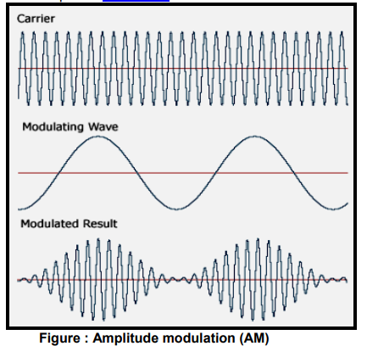

* **Frequency modulation (FM)** Frequency modulation is a type of modulation where the frequency of the carrier is varied in accordance with the modulating signal. The amplitude of the carrier remains constant. The information-bearing signal (the modulating signal) changes the instantaneous frequency of the carrier. Since the amplitude is kept constant, FM modulation is a low-noise process and provides a high quality modulation technique which is used for music and speech in hifidelity broadcasts.

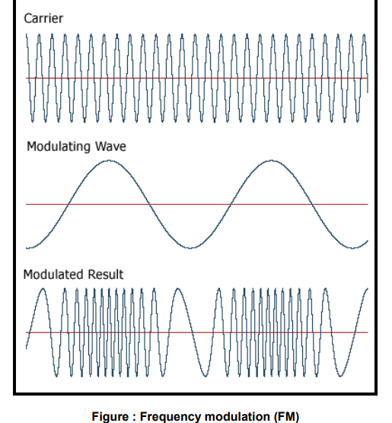

* **Phase modulation (PM).** In phase modulation, the instantaneous phase of a carrier wave is varied from its reference value by an amount proportional to the instantaneous amplitude of the modulating signal.

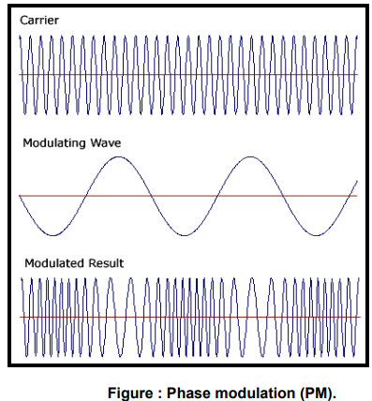

**Digital Modulation Types(Digital to Analog signal conversion)**

Digital modulation is used to convert digital data to analog signal.

It can be accomplished in the following ways:

* Amplitude Shift Keying (ASK)
* Binary ASK (BASK)
* Frequency Shift Keying (FSK)
* Phase Shift Keying (PSK)
* **Amplitude Shift Keying (ASK)** In amplitude shift keying, the amplitude of the carrier signal is varied to create signal elements. Both frequency and phase remain constant while the amplitude changes.
* **Binary ASK** - is normally implemented using only two levels and is hence called binary amplitude shift keying. Bit 1 is transmitted by a carrier of one particular amplitude. To transmit Bit 0 we change the amplitude keeping the freqQ\ uency is kept constant

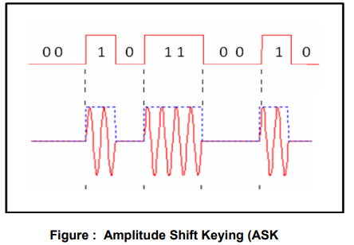

* **Frequency Shift Keying (FSK)** In Frequency shift keying, we change the frequency of the carrier wave. Bit 0 is represented by a specific frequency, and bit 1 is represented by a different frequency. In the figure below frequency used for bit 1 is higher than frequency used for bit 0

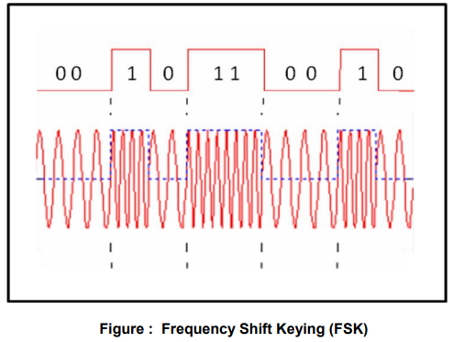

* **Phase Shift Keying (PSK)** Phase shift keying (PSK) is a method of transmitting and receiving digital signals in which the phase of a transmitted signal is varied to convey information. Both amplitude and frequency remain constant as the phase changes. The simplest from of PSK has only two phases, 0 and 1. If the phase of the wave does not change, then the signal state stays the same (low or high). If the phase of the wave changes by 180 degrees, that is, if the phase reverses, then the signal state changes (from low to high or from high to low)

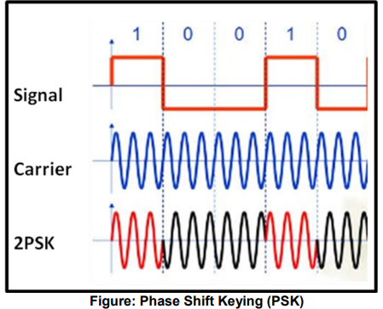

**Analog to Digital Conversion using modulation**

* PAM (Pulse Amplitude Modulation)
* PCM (Pulse Code Modulation)
* PWM (Pulse Width Modulation)

**Pulse Amplitude Modulation** refers to a method of carrying information on a train of pulses, the information being encoded in the amplitude of the pulses.

**PCM** is a general scheme for transmitting analog data in a digital and binary way, independent of the complexity of the analog waveform. With PCM all forms of analog data like video, voice, music and telemetry can be transferred. To obtain PCM from an analog waveform at the source (transmitter), the analog signal amplitude is sampled at regular time intervals. The sampling rate (number of samples per second), is several times the maximum frequency of the analog waveform. The amplitude of the analog signal at each sample is rounded off to the nearest binary level (quantization). The number of levels is always a power of 2 (4, 8, 16, 32, 64, ...). These numbers can be represented by two, three, four, five, six or more binary digits (bits) respectively. At the destination (receiver), a pulse code demodulator converts the binary numbers back into pulses having the same quantum levels as those in the modulator. These pulses are further processed to restore the original analog waveform.

**Pulse Width Modulation** refers to a method of carrying information on a train of pulses, the information being encoded in the width of the pulses. In applications to motion control, it is not exactly information we are encoding, but a method of controlling power in motors without (significant) loss. There are several schemes to accomplish this technique. One is to switch voltage on and off, and let the current recirculate through diodes when the transistors have switched off. Another technique is to switch voltage polarity back and forth with a full-bridge switch arrangement, with 4 transistors.

**NETWORK MODELS**

**Open Systems Interconnection (OSI) Model**

* OSI stands for **Open System Interconnection** is a reference model that describes how information from a [software](https://www.javatpoint.com/software) application in one [computer](https://www.javatpoint.com/what-is-computer) moves through a physical medium to the software application in another computer.
* OSI consists of seven layers, and each layer performs a particular network function.
* OSI model was developed by the International Organization for Standardization (ISO) in 1984, and it is now considered as an architectural model for the inter-computer communications.
* OSI model divides the whole task into seven smaller and manageable tasks. Each layer is assigned a particular task.
* Each layer is self-contained, so that task assigned to each layer can be performed independently.

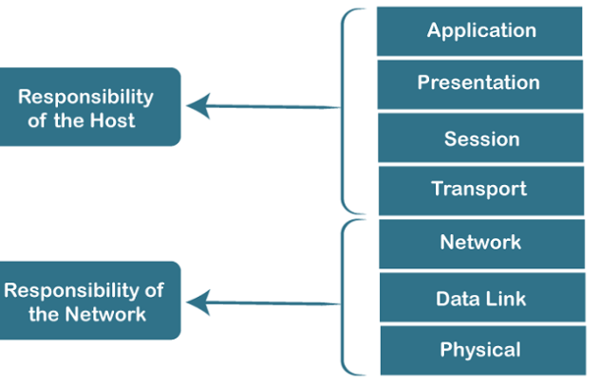

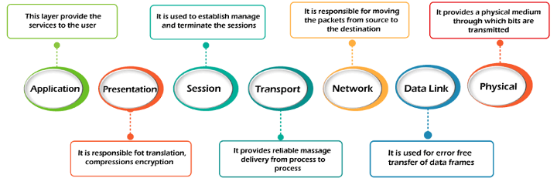

1) Physical layer

* The main functionality of the physical layer is to transmit the individual bits from one node to another node.
* It is the lowest layer of the OSI model.
* It establishes, maintains and deactivates the physical connection.
* It specifies the mechanical, electrical and procedural network interface specifications.

Functions of a Physical layer:

* **Line Configuration:** It defines the way how two or more devices can be connected physically.
* [**Data Transmission**](https://www.javatpoint.com/computer-network-transmission-modes)**:** It defines the transmission mode whether it is simplex, half-duplex or full-duplex mode between the two devices on the network.
* [**Topology**](https://www.javatpoint.com/computer-network-topologies)**:** It defines the way how network devices are arranged.
* **Signals:** It determines the type of the signal used for transmitting the information.

2) Data-Link Layer

* This layer is responsible for the error-free transfer of data frames.
* It defines the format of the data on the network.
* It provides a reliable and efficient communication between two or more devices.
* It is mainly responsible for the unique identification of each device that resides on a local network.
* It contains two sub-layers:
  + **Logical Link Control Layer**
    - It is responsible for transferring the packets to the Network layer of the receiver that is receiving.
    - It identifies the address of the network layer protocol from the header.
    - It also provides flow control.
  + **Media Access Control Layer**
    - A Media access control layer is a link between the Logical Link Control layer and the network's physical layer.
    - It is used for transferring the packets over the network.

Functions of the Data-link layer

* **Framing:** The data link layer translates the physical's raw bit stream into packets known as Frames. The Data link layer adds the header and trailer to the frame. The header which is added to the frame contains the hardware destination and source address.
* **Physical Addressing:** The Data link layer adds a header to the frame that contains a destination address. The frame is transmitted to the destination address mentioned in the header.
* **Flow Control:** Flow control is the main functionality of the Data-link layer. It is the technique through which the constant data rate is maintained on both the sides so that no data get corrupted. It ensures that the transmitting station such as a server with higher processing speed does not exceed the receiving station, with lower processing speed.
* **Error Control:** Error control is achieved by adding a calculated value CRC (Cyclic Redundancy Check) that is placed to the Data link layer's trailer which is added to the message frame before it is sent to the physical layer. If any error seems to occurr, then the receiver sends the acknowledgment for the retransmission of the corrupted frames.
* **Access Control:** When two or more devices are connected to the same communication channel, then the data link layer protocols are used to determine which device has control over the link at a given time.

3) Network Layer

* It is a layer 3 that manages device addressing, tracks the location of devices on the network.
* It determines the best path to move data from source to the destination based on the network conditions, the priority of service, and other factors.
* The Data link layer is responsible for routing and forwarding the packets.
* Routers are the layer 3 devices, they are specified in this layer and used to provide the routing services within an internetwork.
* The protocols used to route the network traffic are known as Network layer protocols. Examples of protocols are IP and Ipv6.

Functions of Network Layer:

* **Internetworking:** An internetworking is the main responsibility of the network layer. It provides a logical connection between different devices.
* [**Addressing**](https://www.javatpoint.com/network-addressing)**:** A Network layer adds the source and destination address to the header of the frame. Addressing is used to identify the device on the internet.
* [**Routing**](https://www.javatpoint.com/computer-network-routing)**:** Routing is the major component of the network layer, and it determines the best optimal path out of the multiple paths from source to the destination.
* **Packetizing:** A Network Layer receives the packets from the upper layer and converts them into packets. This process is known as Packetizing. It is achieved by internet protocol (IP).

4) Transport Layer

* The Transport layer is a Layer 4 ensures that messages are transmitted in the order in which they are sent and there is no duplication of data.
* The main responsibility of the transport layer is to transfer the data completely.
* It receives the data from the upper layer and converts them into smaller units known as segments.
* This layer can be termed as an end-to-end layer as it provides a point-to-point connection between source and destination to deliver the data reliably.

**The two protocols used in this layer are:**

* **Transmission Control Protocol**
  + It is a standard protocol that allows the systems to communicate over the internet.
  + It establishes and maintains a connection between hosts.
  + When data is sent over the TCP connection, then the TCP protocol divides the data into smaller units known as segments. Each segment travels over the internet using multiple routes, and they arrive in different orders at the destination. The transmission control protocol reorders the packets in the correct order at the receiving end.
* **User Datagram Protocol**
  + User Datagram Protocol is a transport layer protocol.
  + It is an unreliable transport protocol as in this case receiver does not send any acknowledgment when the packet is received, the sender does not wait for any acknowledgment. Therefore, this makes a protocol unreliable.

Functions of Transport Layer:

* **Service-point addressing:** Computers run several programs simultaneously due to this reason, the transmission of data from source to the destination not only from one computer to another computer but also from one process to another process. The transport layer adds the header that contains the address known as a service-point address or port address. The responsibility of the network layer is to transmit the data from one computer to another computer and the responsibility of the transport layer is to transmit the message to the correct process.
* **Segmentation and reassembly:** When the transport layer receives the message from the upper layer, it divides the message into multiple segments, and each segment is assigned with a sequence number that uniquely identifies each segment. When the message has arrived at the destination, then the transport layer reassembles the message based on their sequence numbers.
* **Connection control:** Transport layer provides two services Connection-oriented service and connectionless service. A connectionless service treats each segment as an individual packet, and they all travel in different routes to reach the destination. A connection-oriented service makes a connection with the transport layer at the destination machine before delivering the packets. In connection-oriented service, all the packets travel in the single route.
* **Flow control:** The transport layer also responsible for flow control but it is performed end-to-end rather than across a single link.
* **Error control:** The transport layer is also responsible for Error control. Error control is performed end-to-end rather than across the single link. The sender transport layer ensures that message reach at the destination without any error.

5) Session Layer

* It is a layer 3 in the OSI model.
* The Session layer is used to establish, maintain and synchronizes the interaction between communicating devices.

Functions of Session layer:

* **Dialog control:** Session layer acts as a dialog controller that creates a dialog between two processes or we can say that it allows the communication between two processes which can be either half-duplex or full-duplex.
* **Synchronization:** Session layer adds some checkpoints when transmitting the data in a sequence. If some error occurs in the middle of the transmission of data, then the transmission will take place again from the checkpoint. This process is known as Synchronization and recovery.

6) Presentation Layer

* A Presentation layer is mainly concerned with the syntax and semantics of the information exchanged between the two systems.
* It acts as a data translator for a network.
* This layer is a part of the operating system that converts the data from one presentation format to another format.
* The Presentation layer is also known as the syntax layer.

Functions of Presentation layer:

* **Translation:** The processes in two systems exchange the information in the form of character strings, numbers and so on. Different computers use different encoding methods, the presentation layer handles the interoperability between the different encoding methods. It converts the data from sender-dependent format into a common format and changes the common format into receiver-dependent format at the receiving end.
* **Encryption:** Encryption is needed to maintain privacy. Encryption is a process of converting the sender-transmitted information into another form and sends the resulting message over the network.
* **Compression:** Data compression is a process of compressing the data, i.e., it reduces the number of bits to be transmitted. Data compression is very important in multimedia such as text, audio, video.

7) Application Layer

* An application layer serves as a window for users and application processes to access network service.
* It handles issues such as network transparency, resource allocation, etc.
* An application layer is not an application, but it performs the application layer functions.
* This layer provides the network services to the end-users.

Functions of Application layer:

* **File transfer, access, and management (FTAM):** An application layer allows a user to access the files in a remote computer, to retrieve the files from a computer and to manage the files in a remote computer.
* **Mail services:** An application layer provides the facility for email forwarding and storage.
* Directory services: An application provides the distributed database sources and is used to provide that global information about various objects.

**TCP/IP MODEL**

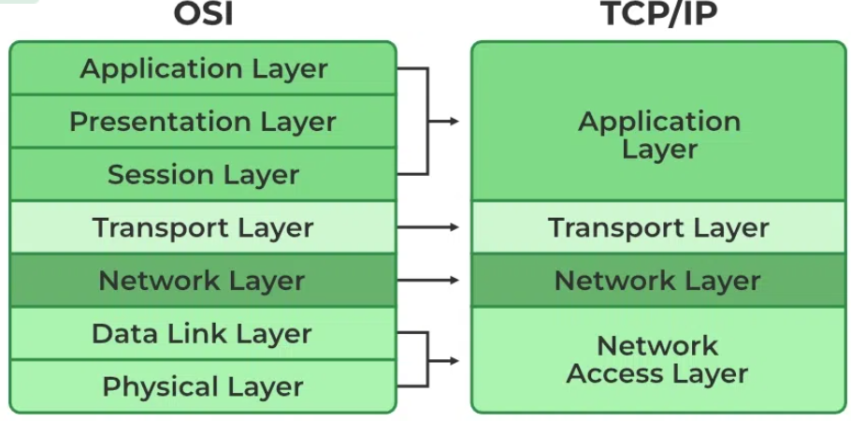

Network Access Layer

* A network layer is the lowest layer of the TCP/IP model.
* A network layer is the combination of the Physical layer and Data Link layer defined in the OSI reference model.
* It defines how the data should be sent physically through the network.
* This layer is mainly responsible for the transmission of the data between two devices on the same network.
* The functions carried out by this layer are encapsulating the IP datagram into frames transmitted by the network and mapping of IP addresses into physical addresses.
* The protocols used by this layer are ethernet, token ring, FDDI, X.25, frame relay.

Internet Layer/ network layer.

* An internet layer is the second layer of the TCP/IP model.
* The main responsibility of the internet layer is to send the packets from any network, and they arrive at the destination irrespective of the route they take.

## Transport Layer

The transport layer is responsible for the reliability, flow control, and correction of data which is being sent over the network.

The two protocols used in the transport layer are **User Datagram protocol and Transmission control protocol**.

Application Layer

* An application layer is the topmost layer in the TCP/IP model.
* It is responsible for handling high-level protocols, issues of representation.
* This layer allows the user to interact with the application.
* When one application layer protocol wants to communicate with another application layer, it forwards its data to the transport layer.
* There is an ambiguity occurs in the application layer. Every application cannot be placed inside the application layer except those who interact with the communication system. For example: text editor cannot be considered in application layer while web browser using **HTTP** protocol to interact with the network where **HTTP** protocol is an application layer protocol.